WEEK NUMBER: | 9
STUDENT NAME: | Anas Al Azad
STUDENT ID: | [YOUR STUDENT ID]
Week 9 – Reinforcement learning with Gymnasium (Q-learning)
My checklist for this week – ticked = done (the completed notebook, plots and scripts are in the Lab 9 folder of my repo), unticked = still on my to-do list.
LAB 9 CHECKLIST (☒ = done, ☐ = still to do) |  | STATUS
☒ | Read the Week 9 tutorial (Gymnasium API: make / reset / step, terminated vs truncated, built-in environments) | Done
☒ | Task 1: filled in QLearningAgent – get_value, update, get_best_action, get_action (ε-greedy) | Done
☒ | Task 1: filled in play_and_train, trained on Taxi-v4 – passes the notebook's check (mean reward 7.78 ≥ 4.5) | Done
☒ | Watched my trained taxi pick up and drop off the passenger (10 steps, reward 11) | Done
☒ | CartPole: per-dimension discretizer + ε decay → ewma 135.9 (target ≥ 50) | Done
☒ | Extra: Expected Value SARSA vs Q-learning on CliffWalking (with the notebook's benchmark_agents helper) | Done
☒ | Task 2 prep: requirements.txt + screenshot_demo_gym_check.py for my laptop | Done
☐ | Task 2: install gymnasium + friends on my laptop and run the check script | To do
☐ | Task 2: run Lab_Week 9.ipynb locally in Jupyter (not Colab) | To do
☐ | Task 1 (in class): run the notebook in Google Colab too | To do
☐ | Add my screenshots (yellow boxes below) | To do
Progress: 7/11 items done

WEEK # | 9
Dates covered: | 8-14 October 2026
Lab tasks | What I did | TIME SPENT | Learning & Problems
RL + Gymnasium basics  Week 9 tutorial sheet | - Read about the agent / environment / reward loop and Gymnasium's standard API: gym.make(), env.reset(), env.step(action) → observation, reward, terminated, truncated, info.  - Looked at the 3 environments I used: Taxi-v4 (500 discrete states, 6 actions), CartPole (4 continuous numbers, 2 actions), CliffWalking (48 states, 4 actions). | 1 h | Learning:  - Gymnasium is the maintained successor of OpenAI Gym – same API for every environment, so one agent works on all of them.  - terminated = the task really ended, truncated = cut off by a time limit.  Problems:  - The notebook text still says Taxi-v3 / OpenAI gym, but current Gymnasium only has Taxi-v4; CartPole-v0 also prints a “v0 is out of date” warning.
Task 1 – Q-learning agent  Lab_Week 9.ipynb, all the <YOUR CODE HERE> blocks | - get_value: V(s) = max over actions of Q(s, a).  - update: Q(s,a) ← (1 − α)·Q(s,a) + α·(r + γ·V(s')).  - get_best_action: the action with the highest Q(s, a).  - get_action: ε-greedy – random action with probability ε, otherwise the best one.  - play_and_train: a = agent.get_action(s) then agent.update(s, a, r, next_s). | 1.5 h | Learning:  - Q-learning is a temporal-difference method: it updates its guess from its own next guess (bootstrapping), no model of the environment needed.  - ε balances exploring vs exploiting.  Problems:  - The hint warns that Q-values can be negative – starting a manual max at 0 would give a wrong V(s), so I used max() over the actual Q-values.  - Used self.env.np_random (as the tip says) instead of random.random(), otherwise seed_everything can't make the runs reproducible.
Taxi-v4  Task 1 | - α = 0.5, γ = 0.99, ε = 0.25 shrinking ×0.99 per episode, 1000 episodes: mean reward of the last 100 = 7.78, so the notebook's assert (≥ 4.5) passes; visited 404 of the 500 states (Fig 9.1).  - Watched the greedy agent with visualize_agent: drives to the passenger, picks them up and drops them off in 10 steps, total reward 11 (Fig 9.2). | 0.5 h | Learning:  - Rewards: −1 per step, +20 for a correct drop-off, −10 for illegal pick-up/drop-off – so it learns the shortest route.  Problems:  - visualize_agent clears its cell's output while animating, so my print in the same cell disappeared – moved the print to its own cell.  - The setup cell's !bash ../xvfb start fails outside Colab (*No such file or directory*) – harmless, rendering uses rgb_array so no screen is needed.
CartPole (continuous → discrete)  Discretizer + training | - Plotted the observation histograms from 100k random steps, then changed the Discretizer so each dimension can have its own number of digits.  - Tried 6 settings: everything at 1 digit already beats 50 (ewma ≈ 103), too coarse [0, 0, 1, 0] only ≈ 20. Picked `[0, 1, 2, 1]` (pole angle only spans ±0.2 so it needs 2 digits, cart position is fine as whole numbers) + ε ×0.999 per episode (min 0.01).  - Result: 4,696 states (inside the tip's 10³–10⁴), last-100 mean 105.1, ewma 135.9 (target ≥ 50), best episode 7,664 steps; greedy test over 20 episodes: mean 755 steps (Fig 9.3). | 1.5 h | Learning:  - Too fine = too many states to ever learn, too coarse = can't tell good states from bad.  - Decaying ε lets it exploit what it learned without stopping exploration completely.  Problems:  - Rewards are super noisy (episodes from ~10 to 7,000+ steps), so I judged by the ewma.  - The env is unwrapped (no 200-step limit), so training gets slower as the agent gets better – long episodes.
Extra – EV-SARSA vs Q-learning  CliffWalking-v1 | - Wrote EVSarsaAgent (only get_value changes: expected Q under the ε-greedy policy instead of the max) and compared it with Q-learning using the notebook's unused benchmark_agents helper (3 seeds × 500 episodes).  - Average reward over the last 100 episodes: Q-learning −104.6 vs EV-SARSA −30.5 (Fig 9.4).  - Greedy paths: Q-learning walks right along the cliff edge (13 steps), EV-SARSA one row further away (15 steps) (Fig 9.5). | 1.5 h | Learning:  - Q-learning is off-policy (learns the optimal path but keeps falling off while still exploring); EV-SARSA is on-policy (learns the safer path for the policy it actually follows).  Problems:  - CliffWalking has no time limit, and the first episodes with an untrained agent wander for a long time (rewards around −2000), so the start of the plot is squashed.
Task 2 – at home  local install | - Made requirements.txt for the whole repo and screenshot_demo_gym_check.py: prints the versions, creates Taxi / CartPole / CliffWalking and trains a numpy Q-table on Taxi (≈ 1 s, mean reward 8.0).  - Still to do: install everything on my laptop, run the check script and the notebook in local Jupyter (screenshots 9.5, 9.6). | 0.5 h | Learning:  - pip install "gymnasium[classic-control,toy-text]" pulls in pygame for rendering.  Problems:  - None really for this one.
TOTAL TIME THIS WEEK |  | 6.5 h | + ~40 min local install & screenshots

Screenshots:
Figures 9.1–9.5 come straight out of my completed Lab_Week 9.ipynb. The yellow boxes are screenshots I still need to add (9.1–9.4 from the notebook, 9.5–9.6 from my laptop for Task 2).
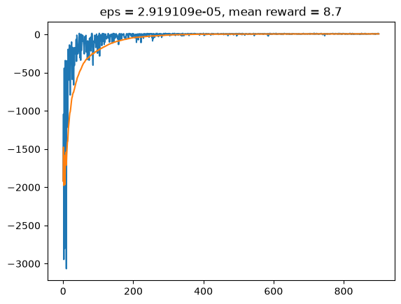
Figure 9.1 – Taxi-v4 training rewards (blue) and moving average (orange)
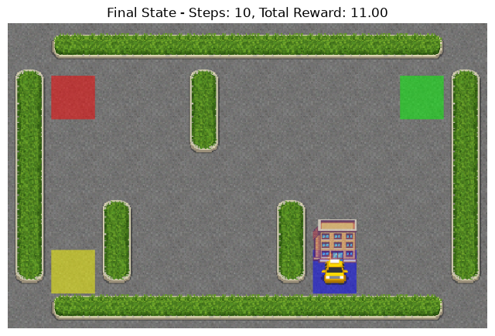
Figure 9.2 – my trained taxi after dropping off the passenger – 10 steps, reward 11
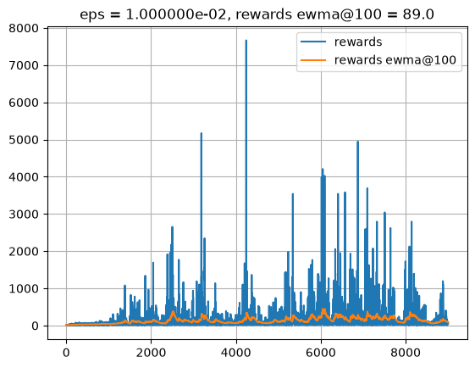
Figure 9.3 – CartPole training with my discretizer (the notebook redraws every 1000 episodes – final ewma 135.9)
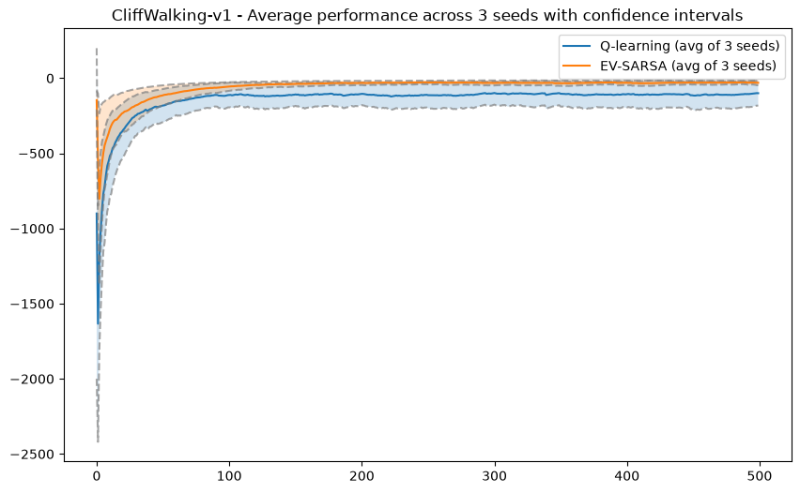
Figure 9.4 – Q-learning vs Expected Value SARSA on CliffWalking (mean of 3 seeds ± std)
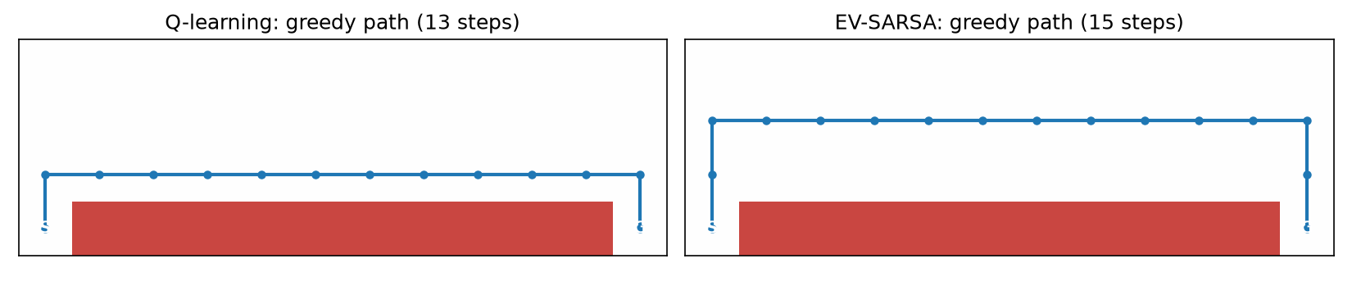
Figure 9.5 – greedy paths: Q-learning hugs the cliff (red), EV-SARSA keeps one row away
[SCREENSHOT 9.1] My completed Q-learning code
What to capture: turn on line numbers, then the QLearningAgent cell lines 47–103 (get_value, update, get_best_action) as 9.1a, lines 107–140 (get_action) as 9.1b, and the play_and_train cell lines 10–25 as 9.1c.
Save as Lab 9/screenshots/9.1a_qlearning_code.png (+ 9.1b, 9.1c) then run python _tools/insert_screenshots.py (or just paste the image here and delete this box).
Screenshot 9.1 – My completed Q-learning code
[SCREENSHOT 9.2] Taxi training (Task 1)
What to capture: the Taxi training cell with its reward plot and no AssertionError, plus the next cell's output (mean reward of the last 100 episodes ≈ 7.78).
Save as Lab 9/screenshots/9.2_taxi_training.png then run python _tools/insert_screenshots.py (or just paste the image here and delete this box).
Screenshot 9.2 – Taxi training (Task 1)
[SCREENSHOT 9.3] CartPole with my discretizer
What to capture: my Discretizer code (lines 13–19 of that cell) + the training plot, and the “How did it go?” output (ewma ≈ 135.9).
Save as Lab 9/screenshots/9.3_cartpole_training.png then run python _tools/insert_screenshots.py (or just paste the image here and delete this box).
Screenshot 9.3 – CartPole with my discretizer
[SCREENSHOT 9.4] Extra – EV-SARSA vs Q-learning
What to capture: the CliffWalking benchmark plot, the two average-reward lines and the greedy-path picture.
Save as Lab 9/screenshots/9.4_evsarsa_vs_qlearning.png then run python _tools/insert_screenshots.py (or just paste the image here and delete this box).
Screenshot 9.4 – Extra – EV-SARSA vs Q-learning
[SCREENSHOT 9.5] Task 2 – libraries installed on my laptop
What to capture: terminal: the end of the pip install + full output of python screenshot_demo_gym_check.py down to “Gymnasium works locally”.
Save as Lab 9/screenshots/9.5_local_gym_check.png then run python _tools/insert_screenshots.py (or just paste the image here and delete this box).
Screenshot 9.5 – Task 2 – libraries installed on my laptop
[SCREENSHOT 9.6] Task 2 – the notebook running locally
What to capture: the notebook open in Jupyter on your laptop (address bar shows localhost:8888) with the Taxi training cell finished.
Save as Lab 9/screenshots/9.6_local_jupyter_run.png then run python _tools/insert_screenshots.py (or just paste the image here and delete this box).
Screenshot 9.6 – Task 2 – the notebook running locally

